Operational Concept Description (OCD)



PROJECT TITLE
LEMA FAMILY ACCOUNTABILITY SYSTEM
TEAM NO
#04

TEAM MEMBERS & ROLES
NAME | ROLES
Teawon Han | Project Manager
Zhen Huang | Feasibility Analyst
Ziming Wei | Operational Concept Engineer
Xiali Ma | Life Cycle Planner
Ying Yang | Life Cycle Planner
Ian Williams | Requirements Engineer
Kimberly Krause | IIV&V /  System Requirements Engineer

<12/05/2011>

Version History
Date | Author | Version | Changes made | Rationale
09/28/11 | Ziming Wei | 1.1 | - Build initial version of OCD for LEMA project | - Initial version of OCD
09/30/11 | Teawon Han | 1.2 | - Review format of document and update history section. | - Update report format by using consistence terms and expressions.
10/07/11 | Ziming Wei | 2.1 | - Complete system transformation section. | - Build new operational concept for the system
10/13/11 | Ziming Wei | 2.2 | - Updated the capability goals and fixed bugs.  - Updated 2.4, 3.3. | - Fixed bugs and updated diagrams.
10/24/11 | Ziming Wei | 2.3 | - Updated 2.3, 2.4, 2.5, 3.2, 3.3, 3.4 | - Updated the document and fixed bugs
11/21/11 | Ziming Wei | 3.1 | - Updated 2.5, 3.3, 3.4 | - Updated new system workflow, modified other parts according to new requirements.
12/05/11 | Ziming Wei | 3.2 | - Updated 2.3, 3.4.2 | - Updated according to latest SSAD

Table of Contents
Operational Concept Description (OCD) i
Version History ii
Table of Contents iii
Table of Tables iv
Table of Figures v
1. Introduction 1
1.1 Purpose of the OCD 1
1.2 Status of the OCD 1
2. Shared Vision 2
2.1 Success-Critical Stakeholders 2
2.2 System Capability Description 2
2.3 Expected Benefits 3
2.4 Benefits Chain 4
2.5 System Boundary and Environment 5
3. System Transformation 6
3.1 Information on Current System 6
3.2 System Objectives, Constraints and Priorities 9
3.3 Proposed New Operational Concept 12
3.4 Organizational and Operational Implications 15

Table of Tables
Table 1: Success-Critical Stakeholders 2
Table 2: Level of Service Goals 10
Table 3: Relation to Current System 11

Table of Figures
Figure 1: Benefits Chain Diagram of LEMA Integrated Family Accountability System 4
Figure 2: System Boundary and Environment Diagram of LEMA Integrated Family Accountability System 5
Figure 3: Parents Notification Workflow 7
Figure 4: Data Input Workflow 8
Figure 5: Element Relationship Diagram of LEMA Integrated Family Accountability System 12
Figure 6: Data Input Workflow 13
Figure 7: Parents Notification Workflow 14
Figure 8: Reservation Workflow 15

Introduction

Purpose of the OCD
This document provides, in detail, the shared visions and goals of the success-critical stakeholders of LEMA Pilot School Integrated Family Accountability System. The success-critical stakeholders of the project are Beth B. Kennedy and Scott Petri, as the client; the teachers, students, parents and other staff of LEMA Pilot School, as users; and team 4 in CSCI 577, as the developer team.

Status of the OCD
The status of the OCD is currently at the version number 3.2 in the foundation phase. The current system has been analyzed. We have established new operational concept for the proposed system.

Shared Vision

Success-Critical Stakeholders
Table 1: Success-Critical Stakeholders
Stakeholder | Authorized Representatives | Organization | Relation to Benefits Chain
Teachers | Beth B. Kennedy, Scott Petri | LEMA Pilot School | - Provide information and feedback to the development team.  - Provide training to the future users.  - Get better information about students’ performance
Development team | N/A: students of team 4 in CSCI577 | University of Southern California | - Develop the system  - Provide training
Students | N/A: students of LEMA Pilot School | LEMA Pilot School | - Get more information about performance
Parents | N/A: students of LEMA Pilot School | LEMA Pilot School | - Get more interactions with teachers

System Capability Description
- The type of system to be built:
- The new system will assemble information about students such as attendance, grades, etc. from teachers into a central database. It will reduce time and simplify the currently complex procedure for teachers collecting students’ data.
- The new system will provide students’ performance reports in an understandable way for teachers, students and parents.
- The new system will provide a function for teachers to notify parents via email and text.
- The new system will provide user-friendly graphic interfaces for teachers, students and parents.
- The new system will be able to track the resources (books, computers, etc.) students have borrowed from the school.
- The new system will provide security mechanism to make sure that all data in the system is well protected.
- The target customers for the system:
- The target customers will be the teachers, students, parents and other school staff of LEMA School.
- The need or opportunity that will be satisfied by the system:
- Teachers’ need to manage students’ information online.
- Students and parents’ need to access students’ performance online.
- Easier way for teachers to notify parents.
- A compelling reason for the customer to use the system:
- Currently, teachers cannot easily gather students’ information, nor can they provide students’ performance efficiently.
- Current parent notification is a complex, time-consuming procedure.

Expected Benefits
- The teachers will spend less time gathering students’ grades, attendance, notifying parents via email and text, thus, they will have more time to improve the courses.
- The parents will get timely information about their children’s performance at school, so they will know their children’s status better.
- The teachers, parents, and students will be able to know students’ performance easily online, and in different kinds of reports which provide more useful information.
- The teachers and students will be able to track the resources that students have borrowed from the school.

Benefits Chain
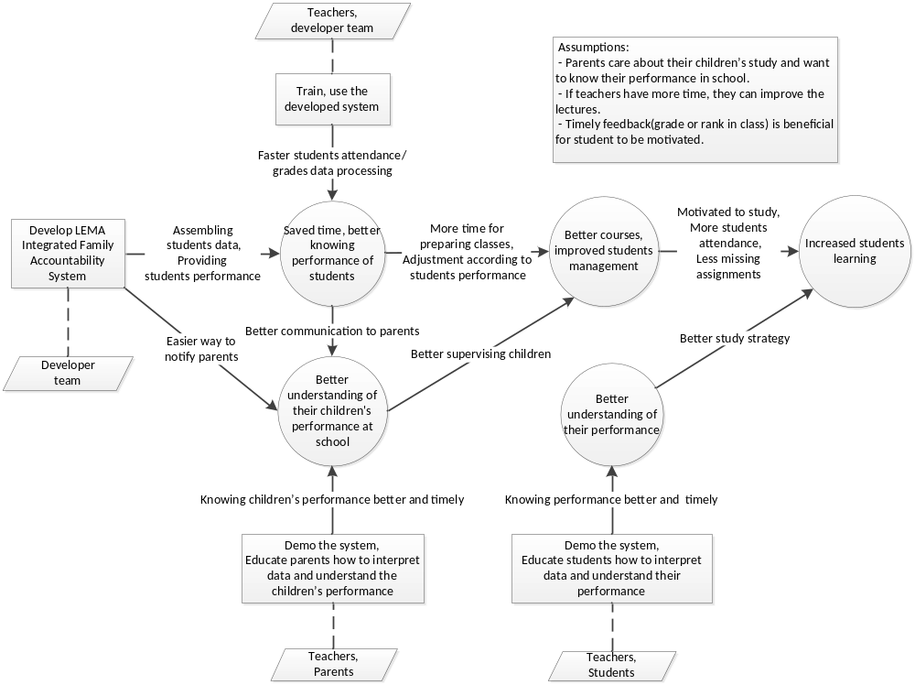
Figure 1: Benefits Chain Diagram of LEMA Integrated Family Accountability System

System Boundary and Environment
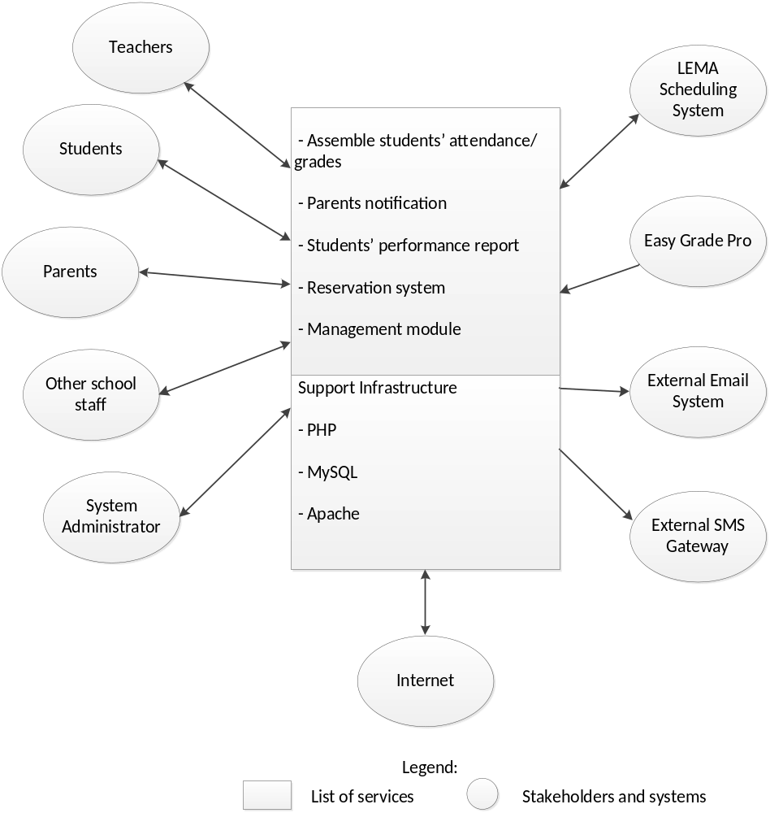
Figure 2: System Boundary and Environment Diagram of LEMA Integrated Family Accountability System

System Transformation

Information on Current System

Infrastructure
Currently the school has two systems.
The first is SCHOOL MAX. This is the system provided by LAUSD and is the system that grades must be input into at the end of each marking period so that student reports are printed.
The second system is Easy Grade Pro. This system was bought by LEMA because teachers did not feel SCHOOL MAX had the features they needed. EZ Grade Pro is much better for maintaining a daily account of students’ attendance and grades and it provides many reports to display information. But the students’ data are in the separated computers, so each teacher cannot see the attendance or grades of other teachers.

Artifacts

Artifact | Description | Requested/ Shown/ Receive | Planned Delivery Date
Reports generate by MyData. | Student information such as state test scores, student grades, attendance, A-G coursework, periodic assessments, English Language Learner data, and more.  However, students are not familiar with the system. Therefore, students cannot be motivated to improve their performance and they cannot recognize what their statuses are. That is why our system is needed. | shown | 9/20/2011
School Max | Provides basic information on students and parents (Student Profile; Contact information – phone and address; languages, but not email addresses; Schedule); List by Student Name (alphabetical for students in an individual teacher’s classes); GRADES (Current Grades for specific semester, not cumulative or credits); REPORTS (Pre-defined reports of Attendance Detail, Class Lists; GRADES (for specific date parameters for students in a teacher’s class).  However, this system supports information in every 5 weeks. Therefore, teachers and parents cannot recognize what the students' status is timely. | shown | 9/20/2011
Easy Grade Pro reports | Easy Grade Pro provides standardized reports on missing grades, individual student performance (not attendance) and assignment information.  However, this program is installed in each teacher’s personal computer. So, teachers cannot share the information concurrently. | shown | 9/27/2011

Current Business Workflow
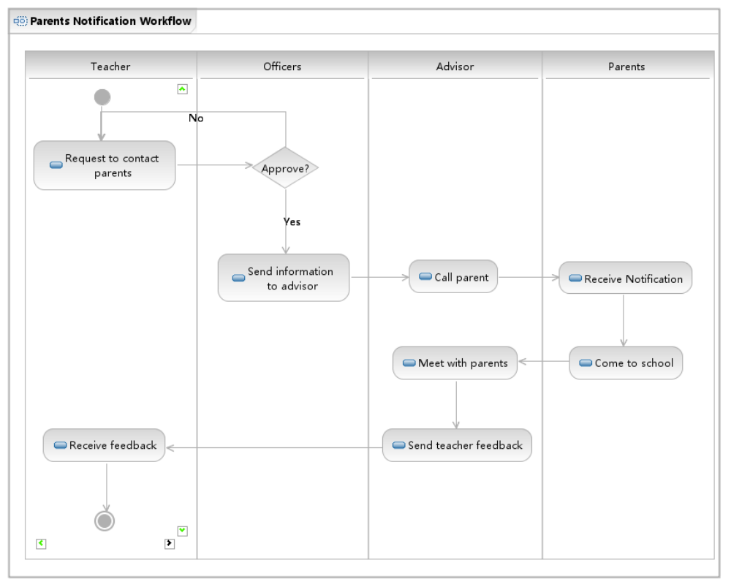
Figure 3: Parents Notification Workflow
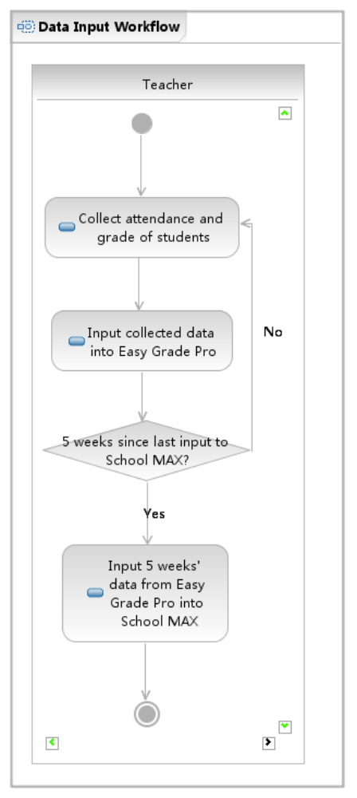
Figure 4: Data Input Workflow

System Objectives, Constraints and Priorities

Capability Goals
OC-1 Multi-School Support: Use school code to support more than one LEMA School in the future.
OC-2 Scatterplot Reporting: The system must show scatterplots that show students where they stand for attendance and grades.
OC-3 Reservation System: The system is able to track books and other resources a student has from the school.
OC-4 Statistical Data: System must have aggregate student data calculations such as average and standard deviation for grades.
OC-5 Pie Chart for Grade Magnitude: System must have a chart that shows how much of a student's grade is made up of each category of work (projects, test, HW, etc.).
OC-6 Daily Reporting: System must have the ability to update student grade/attendance reports daily.
OC-7 Student Progress Over Time: System must show data for student GPA, number of credits completed, and attendance rate for the current term and for previous months.
OC-8 Data Format: Number of missing assignments, tardies, and absences must be a whole number, not a percentage.
OC-9 Level of Access: The system provides 5 levels of access: administrator, supervisor, teacher, student and parent.
OC-10 Import from Easy Grade Pro: The system is able to import text file of students’ grade which is exported from Easy Grade Pro and store that information into database.
OC-11 Missing Assignments: The system must store missing assignments for each student separated by class.

Level of Service Goals
Table 2: Level of Service Goals
Level of Service Goals | Priority Level | Referred SSRD requirements
System response time(6 minutes for max time for generating reports, and 5-10 seconds for other page response) | Must have | LOS-1
Number of students: 300-1000 | Must have | LOS-2

Organizational Goals
OG-1: Save time via more efficient data processing.
OG-2: Improve student management via more useful information and statistics.
OG-3: Better communication with parents via parents notification function.
OG-4: Improve students study by providing more useful data.
OG-5: Help teachers to manage school resources via resource reservation function.

Constraints
CO-1: Budget Constraints: $0 is preferable, $500 is fine, and $4000 is possible.
CO-2: UI Constraints: Interface for teacher should be like Easy Grade Pro, and interface for student and parent should have charts as well as numeric value.
CO-3: Multiple Browsers Support: The new system must support IE, Chrome, and Firefox browsers. (Safari is nice to have.)

Relation to Current System
Table 3: Relation to Current System
Capabilities | Current System | New System
Roles and Responsibilities | Teachers are responsible for data input. But teachers, students and parents cannot get useful information about students. | Teachers are responsible for data input. Students and parents can access to the new system to get performance report.
User Interactions | School Max is very slow. Easy Grade Pro lacks features that teachers want. | Quick response time.  Better reports with more meaningful data.
Infrastructure | Easy Grade Pro is a single-machine Software. School Max is a web-based system. | Web-based system, built on PHP and MySQL
Stakeholder Essentials and Amenities | N/A | Simplified process for teachers to notify parents.  Easier way for users to get more useful performance of students.  Assure data security.
Future Capabilities | N/A | Upgrade input functions to show data while inputting for teachers’ convenience

Proposed New Operational Concept

Element Relationship Diagram
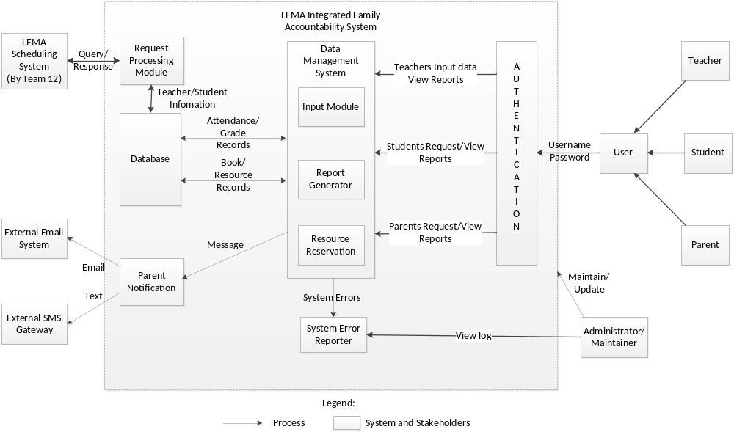
Figure 5: Element Relationship Diagram of LEMA Integrated Family Accountability System

Business Workflows
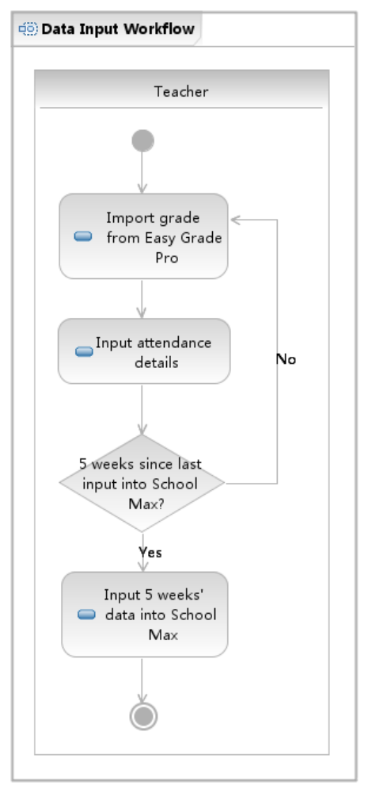
Figure 6: Data Input Workflow
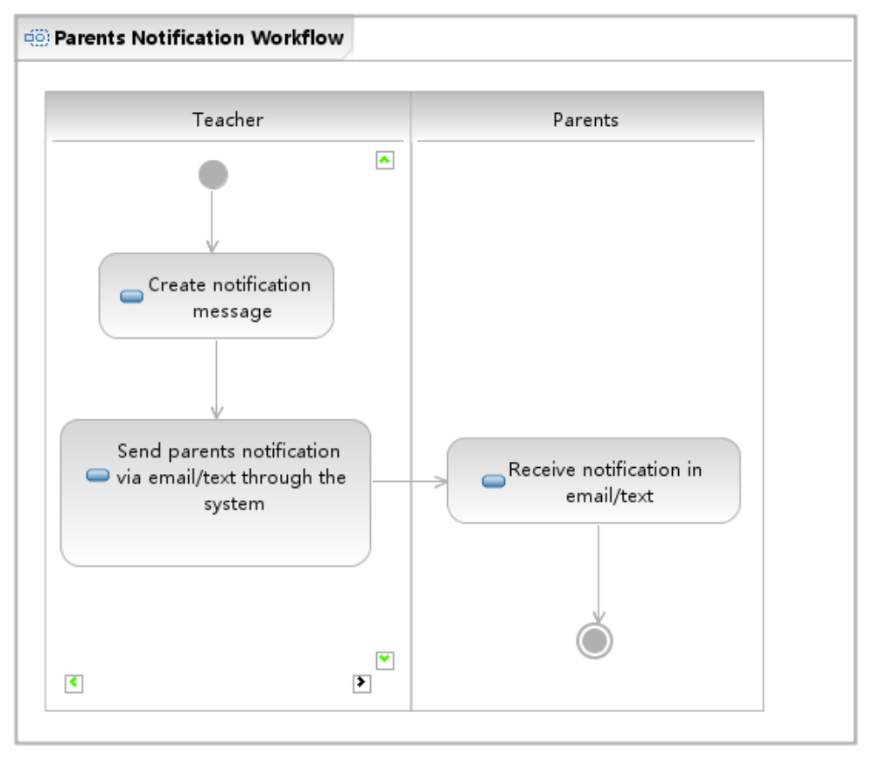
Figure 7: Parents Notification Workflow
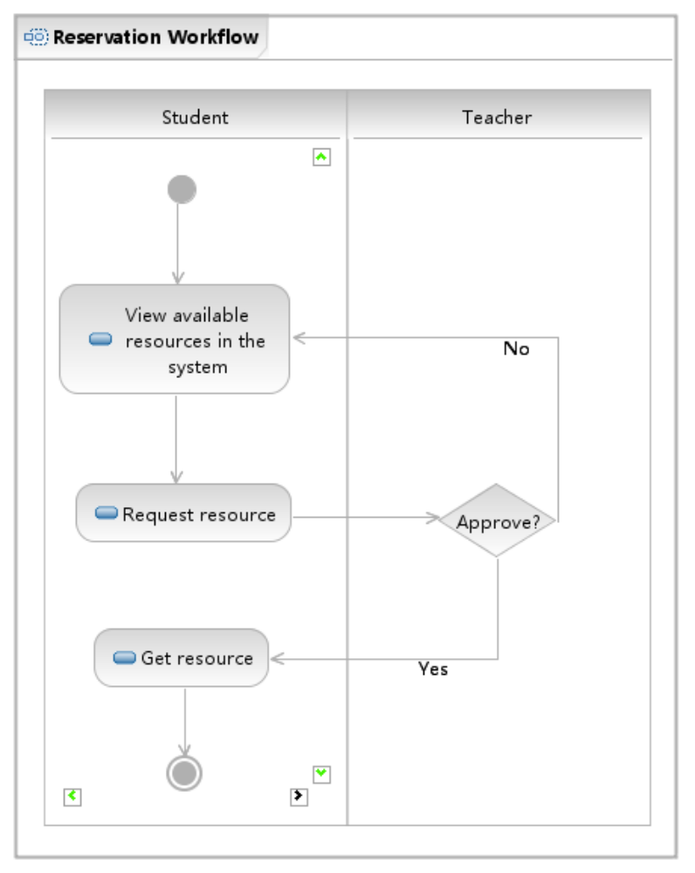
Figure 8: Reservation Workflow

Organizational and Operational Implications

Organizational Transformations
- The need to designate a new system maintainer as well as administrator who will manage the system’s functionalities and users’ access to the system.
- Elimination of the need for teachers to request approbation from other teachers/officers to contact parents.

Operational Transformations
- Teachers need to input students’ attendance into new system and import grade details from Easy Grade Pro.
- Notifying parents via email and text online.
- Enabling teachers, students, parents access the students’ performance online.
- Enabling teachers to manage resources borrowed by the students from the school.

